|  |  |
| --- | --- |
| Activity | Data Type |
| Number of beatings from Wife | Discrete |
| Results of rolling a dice | Discrete |
| Weight of a person | Continuous |
| Weight of Gold | Continuous |
| Distance between two places | Continuous |
| Length of a leaf | Continuous |
| Dog's weight | Continuous |
| Blue Color | Discrete |
| Number of kids | Discrete |
| Number of tickets in Indian railways | Discrete |
| Number of times married | Discrete |
| Gender (Male or Female) | Discrete |

Q1) Identify the Data type for the Following:

Q2) Identify the Data types, which were among the following

Nominal, Ordinal, Interval, Ratio.

|  |  |
| --- | --- |
| Data | Data Type |
| Gender | Nominal |
| High School Class Ranking | Nominal |
| Celsius Temperature | Interval |
| Weight | Ratio |
| Hair Color | Nominal |
| Socioeconomic Status | Ordinal |
| Fahrenheit Temperature | Interval |
| Height | Ratio |
| Type of living accommodation | Nominal |
| Level of Agreement | Nominal |
| IQ(Intelligence Scale) | Interval |
| Sales Figures | Ratio |
| Blood Group | Nominal |
| Time Of Day | Ordinal |
| Time on a Clock with Hands | Interval |
| Number of Children | Ratio |
| Religious Preference | Nominal |
| Barometer Pressure | Interval |
| SAT Scores | Interval |
| Years of Education | Ratio |

Q3) Three Coins are tossed, find the probability that two heads and one tail are obtained?

**ANS: HHT + HTH + THH**

**= 1/8+1/8+1/8**

**= 3/8**

Q4) Two Dice are rolled, find the probability that sum is

1. Equal to 1

**ANS: When two dice are rolled, sample space is given as:**

**(1,1) (1,2) (1,3) (1,4) (1,5) (1,6)**

**(2,1) (2,2) (2,3) (2,4) (2,5) (2,6)**

**(3,1) (3,2) (3,3) (3,4) (3,5) (3,6)**

**(4,1) (4,2) (4,3) (4,4) (4,5) (4,6)**

**(5,1) (5,2) (5,3) (5,4) (5,5) (5,6)**

**(6,1) (6,2) (6,3) (6,4) (6,5) (6,6)**

**Therefore, Total number of possible outcomes = 36**

**Favorable Cases = Sum is equal to 1 = 0**

**No Probability means 0 probability.**

1. Less than or equal to 4

**ANS: When two dice are rolled, sample space is given as:**

**(1,1) (1,2) (1,3) (1,4) (1,5) (1,6)**

**(2,1) (2,2) (2,3) (2,4) (2,5) (2,6)**

**(3,1) (3,2) (3,3) (3,4) (3,5) (3,6)**

**(4,1) (4,2) (4,3) (4,4) (4,5) (4,6)**

**(5,1) (5,2) (5,3) (5,4) (5,5) (5,6)**

**(6,1) (6,2) (6,3) (6,4) (6,5) (6,6)**

**Therefore, Total number of possible outcomes = 36**

1. **Favorable Cases = Sum is** **Less than or equal to 4**

**= (1,3) (2,2) (3,1) (1,2) (2,1) (1,1)**

**Probability = 6/36 = 1/6**

1. Sum is divisible by 2 and 3

**ANS:** **When two dice are rolled, sample space is given as:**

**(1,1) (1,2) (1,3) (1,4) (1,5) (1,6)**

**(2,1) (2,2) (2,3) (2,4) (2,5) (2,6)**

**(3,1) (3,2) (3,3) (3,4) (3,5) (3,6)**

**(4,1) (4,2) (4,3) (4,4) (4,5) (4,6)**

**(5,1) (5,2) (5,3) (5,4) (5,5) (5,6)**

**(6,1) (6,2) (6,3) (6,4) (6,5) (6,6)**

**Therefore, Total number of possible outcomes = 36**

**Favorable outcomes = sum is divisible by 2 and 3**

**Sum should be divisible by both 2 and 3**

**Favorable outcomes = (1,5), (2,4), (3,3), (4,2), (5,1), (6,6) Therefore,**

**Number of favorable outcomes = 6**

**The probability of an event is given as:**

**Probability = number of favorable outcomes**

**Number of possible outcomes**

**Probability = 6/36**

**Thus the probability that sum is divisible by 2 and 3 is 1/6**

Q5) A bag contains 2 red, 3 green and 2 blue balls. Two balls are drawn at random. What is the probability that none of the balls drawn is blue?

**ANS:**

**Total number of balls = (2 + 3 + 2) = 7**

**Let ‘S’ be the sample space**

**To find number of different combinations → nCr=n!/ r!(n−r)!**

**Then, n(S) = Number of ways of drawing 2 balls out of 7 = 7C2**

**n(S)= 7!/ 2!(7-1)! = (7×6) / (2×1) = 21**

**Let E = Event of drawing 2 balls in which none of them is blue.**

**Therefore, n(E) = Number of ways of drawing 2 balls out of (2 + 3) balls.**

**N(E) = 5C2 = (5×4) / (2×1) = 10**

**P(E) = n(E) / n(S)= 10 / 21 = 0.47**

Q6) Calculate the Expected number of candies for a randomly selected child

Below are the probabilities of count of candies for children (ignoring the nature of the child-Generalized view)

|  |  |  |
| --- | --- | --- |
| CHILD | Candies count | Probability |
| A | 1 | 0.015 |
| B | 4 | 0.20 |
| C | 3 | 0.65 |
| D | 5 | 0.005 |
| E | 6 | 0.01 |
| F | 2 | 0.120 |

Child A – probability of having 1 candy = 0.015.

Child B – probability of having 4 candies = 0.20

**ANS: Expected number of candies for a randomly selected child should be**

**= 1*0.015 + 4*0.20 + 3*0.65 + 5*0.005 + 6* 0.01 + 2*0.120**

**= 3.09**

Q7) Calculate Mean, Median, Mode, Variance, Standard Deviation, Range & comment about the values / draw inferences, for the given dataset

* For Points,Score,Weigh>

Find Mean, Median, Mode, Variance, Standard Deviation, and Range and also Comment about the values/ Draw some inferences.

**Use Q7.csv file**

**ANS:**

**1) Points :-**

**Mean = 3.596563**

**Median = 3.695**

**Mode = 3.07**

**Variance = 0.285881**

**Standard Deviation = 0.534679**

**Range = 2.17**

**2) Score:-**

**Mean = 3.21725**

**Median = 3.325**

**Mode = 3.44**

**Variance = 0.957379**

**Standard Deviation = 0.978457**

**Range = 3.911**

**3) Weigh:-**

**Mean = 17.84875**

**Median = 17.71**

**Mode = 17.02**

**Variance = 3.193166**

**Standard Deviation = 1.786943**

**Range = 8.4**

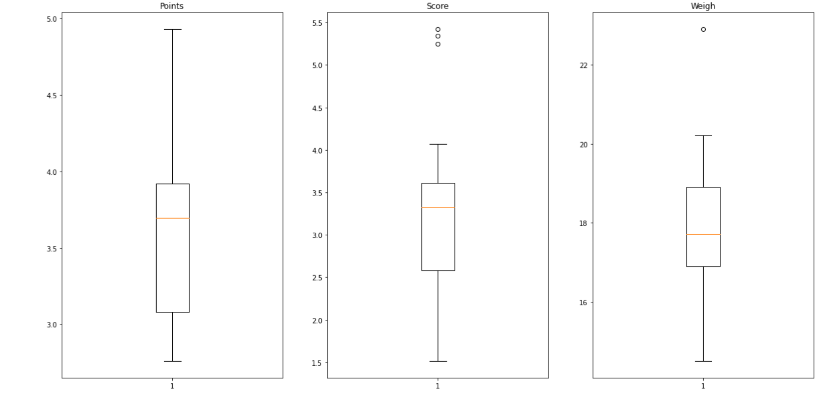

**Q8)** Calculate Expected Value for the problem below

1. The weights (X) of patients at a clinic (in pounds), are

108, 110, 123, 134, 135, 145, 167, 187, 199

Assume one of the patients is chosen at random. What is the Expected Value of the Weight of that patient?

**ANS: Mean = (108+110+123+134+135+145+167+187+199)/9**

**= 1308/9**

**= 145.3**

**Mue = 145.3**

Q9) Calculate Skewness, Kurtosis & draw inferences on the following data

Cars speed and distance

Use Q9_a.csv

SP and Weight (WT)

Use Q9_b.csv

**ANS:**

1. **Inference:**

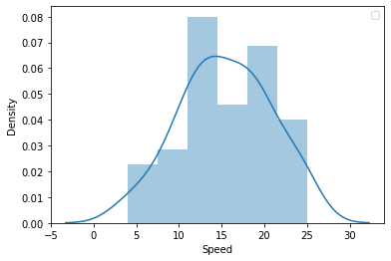

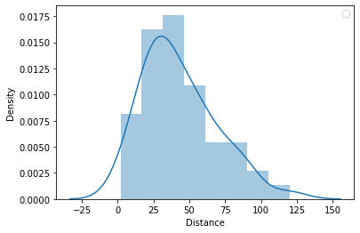

**b)**

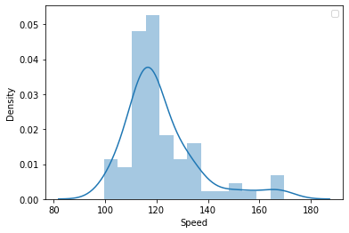

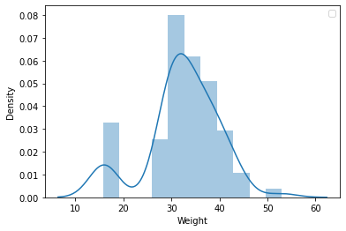

Q10) Draw inferences about the following boxplot & histogram

**ANS: Histogram of ChickWeight$weight**

* **Chick Weight data is Rightly Skewed or positively skewed**
* **More than the 50% Chick Weight is in between 50 to 150**
* **Most of the Chick Weight is between 50 to 100**



**ANS:**

* **Above shown data is Rightly Skewed**
* **Outliers are present at the upper side**

**Q11)** Suppose we want to estimate the average weight of an adult male in Mexico. We draw a random sample of 2,000 men from a population of 3,000,000 men and weigh them. We find that the average person in our sample weighs 200 pounds, and the standard deviation of the sample is 30 pounds. Calculate 94%,98%,96% confidence interval?

**ANS:**

* **Confidence interval for 94% is:**

**(198.43943840429978, 201.56056159570022)**

* **Confidence interval for 98% is:**

**(198.43943840429978, 201.56056159570022)**

* **Confidence interval for 96% is:**

**(198.62230334813333, 201.37769665186667)**

**Q12)** Below are the scores obtained by a student in tests

**34,36,36,38,38,39,39,40,40,41,41,41,41,42,42,45,49,56**

1. Find mean, median, variance, standard deviation.

**ANS:**

|  |  |
| --- | --- |
| **Mean** | 41.0 |
| **Median** | 40.5 |
| **Variance** | 25.52941 |
| **Standard Deviation** | 5.052664 |

1. What can we say about the student marks?

**ANS: Max. students get 40 marks**

Q13) What is the nature of skewness when mean, median of data are equal?

**ANS: Nature of skewness is symmetric OR Zero Skewed.**

Q14) What is the nature of skewness when mean> median?

**ANS: Nature of skewness is Positively Skewed**

Q15) What is the nature of skewness when median > mean?

**ANS: Nature of skewness is Negatively Skewed**

Q16) What does positive kurtosis value indicates for a data?

**ANS: Data is normally distributed.**

Q17) What does negative kurtosis value indicates for a data?

**ANS: Distribution of the data has lighter tail & flatter peak than the normal distribution.**

Q18) Answer the below questions using the below boxplot visualization.



What can we say about the distribution of the data?

**ANS: If we consider the above shown boxplot is of marks of students in a class then we can say that, 50% of students in a class having marks more than 10 & remaining are less.**

What is nature of skewness of the data?

**ANS: Negatively skewed (Median > Mean)**

What will be the IQR of the data (approximately)?   
**ANS:**  **IQR = Q3-Q1**

**= 10-18**

**= -8**

Q19) Comment on the below Boxplot visualizations?



Draw an Inference from the distribution of data for Boxplot 1 with respect Boxplot 2.

**ANS:**

* **There are no outliers are available in the both plots.**
* **By seeing both plots we can say that approximately median is same.**
* **Both plots are normally distributed.**

Q 20) Calculate probability from the given dataset for the below cases

Data _set: Cars.csv

Calculate the probability of MPG of Cars for the below cases.

MPG <- Cars$MPG

* 1. P(MPG>38)

**ANS: Probability for MPG>38 is: 0.3475939251582705**

* 1. P(MPG<40)

**ANS: Probability for MPG<40 is: 0.7293498762151616**

* 1. (20<MPG<50)

**ANS: Probability for 20<MPG<50 is: 0.013116469610523339**

Q 21) Check whether the data follows normal distribution

1. Check whether the MPG of Cars follows Normal Distribution

Dataset: Cars.csv

**ANS:**

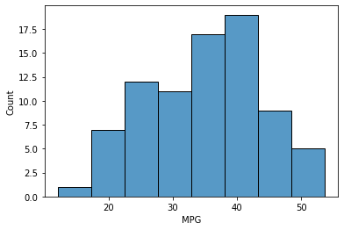

* **The data set is not normally distributed, it is rightly skewed or positively skewed.**

1. Check Whether the Adipose Tissue (AT) and Waist Circumference(Waist) from wc-at data set follows Normal Distribution

Dataset: wc-at.csv

**ANS:**

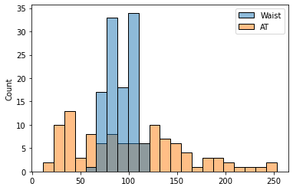

* **Both the Adipose Tissue (AT) and Waist Circumference(Waist) data set do not follow the normal distribution approximately.**

Q 22) Calculate the Z scores of 90% confidence interval,94% confidence interval, 60% confidence interval

**ANS:**

* **The Z scores of 90% confidence interval = 1.64**
* **The Z scores of 94% confidence interval = 1.55**
* **The Z scores of 60% confidence interval = 0.25**

Q 23) Calculate the t scores of 95% confidence interval, 96% confidence interval, 99% confidence interval for sample size of 25

**ANS:**

* **95% confidence interval t-score = 2.06**
* **96% confidence interval t-score = 2.17**
* **99% confidence interval t-score = 2.8**

Q 24**)** A Government company claims that an average light bulb lasts 270 days. A researcher randomly selects 18 bulbs for testing. The sampled bulbs last an average of 260 days, with a standard deviation of 90 days. If the CEO's claim were true, what is the probability that 18 randomly selected bulbs would have an average life of no more than 260 days

Hint:

rcode 🡪 pt(tscore,df)

df 🡪 degrees of freedom

**ANS: t=(260-270)/(90/18**0.5)**

**t = -0.4714045207910317**

**p_value = 0.32167411684460556**